Session 4

DML

INSERT
Simple Insert
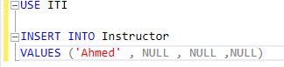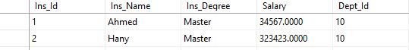
In this type of insert we have to add values in the same order of columns as it is in the diagram of the table & also having to add null to column we don’t want to even insert in it

Column List Insertion
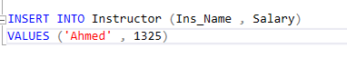

Rules when using column list
If we don’t want to insert a values to a column this Column must be 1 of 5 at least other wise the insert won’t be loaded or executed
Options :
- Has “IDENTITY”
- Has a default value
- Has a timestamp
- Computed Column
- Is nullable

Row Constructor Isert
Insertion of Multiple Line at the same time
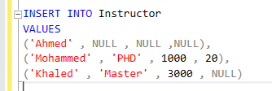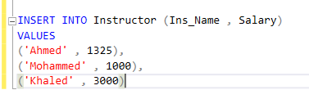

Note: This type of insertion is counted as a 1 Transition meaning that if there is a problem with 1 of values all of these rows will not be saved in the database (ALL-OR-NOTHING)
ALSO row contractor insertion is so much faster when dealing with bulk data insertions
We are talking about 10-100x

UPDATE
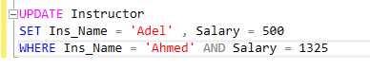

DELETE
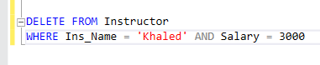

DQL
SELECT Statement
It can be contain the following
1-FROM 2- ON 3-JOIN 4-WHERE 5-GROUP BY
- “WITH CUBE” OR “WITH ROLLUP “ 7-HAVING 8-SELECT
9-DISTINCIT 10-ORDER BY 11-TOP

Note: These are all ordered by the logical Processing Order and it might be deferent depending on the existing of other keyword in the statement

Wildcard Character
- % n of characters
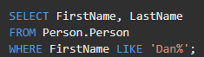
- _ 1 character

- [] match any single character within the specified range or set depending on what u will add in the brackets if “-” that’s range if e didn’t add “-” and we typed [abcdefg] that means I want a to make sure that the string matches any single char within the brackets
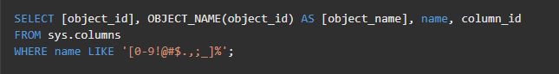
- [^] it’s the same as [] but with NOT
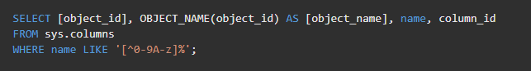

JOINS

- Cross join
Combine rows from the first table with rows from the second table
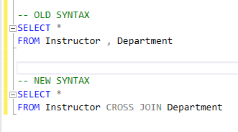
Cross join doesn’t require actual relation between tables you want to join
- Inner join
inner join gets the shared data between the two tables and starting from inner join
they joining requires actual relation between these tables you ant to join
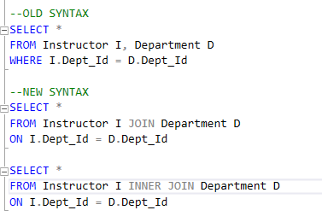
- Left outer join : 
it is built above inner join with a really small deference which that will get all the data from the table to the left of the keyword “JOIN” with the shared data between both tables
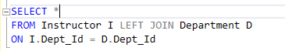
- Right Outer Join: 
same as left outer join but it gets all the data from the table to its right with the shared one with the left
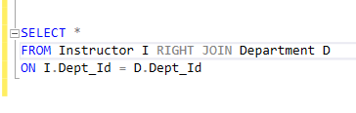
- Full Outer Join: 
gets all the data between the two tables
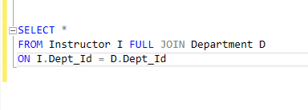
- Self Join:
joining between a table and itself
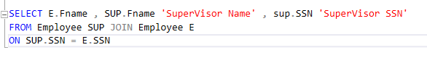
- Multiple Table Join:
Joining between multiple table
